**Quick Start Guide**

**Fore note:**

This guide is intended to help you set up and play with the sample project as quickly as possible. For the quick start to work, you will need the December 2010 version of UDK, as we just copy over the entire folder.

I am targeting only the December 2010 version at the moment because the engines .ini files frequently change between versions of UDK and we will be copying an .ini file over the top of another. You can try this quick start on other version’s of UDK but I cannot guarantee that it won’t break it, so do so at your own risk.

The NIUI project was written using nFringe and Microsoft Visual Studio, so you can use the nFringe project file to easily browse the source code.

**Step 1:**

The first thing that you will need to do is install the Kinect Sensor, OpenNI and NITE binaries. These are the programs that extract the camera information from the Kinect as well as enable skeletal tracking.

*Make sure that your Kinect is unplugged from your computer before you begin this step.*

Open the folder called “**Installers**” found in the download. This will have a subfolder titled “**KinectInstall**” which contains a several files. The one that we are interested in is called “**KinectInstall.exe**”, which is a small program that automates the setup process for OpenNI / NITE / Kinect. Credit for this goes to:

<http://babaandthepigman.wordpress.com/2011/01/26/openni-kinect-getting-set-up-on-windows/>

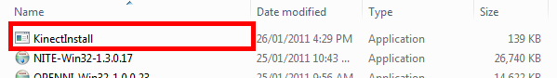

When you run this a small console window should appear and begin installing the OpenNI, NITE and Kinect Driver in the correct order. When this is finished, you can plug your Kinect back into your computer and move on.

**Step 2:**

In the folder this file was found in (**Quick Start**) there should be another folder titled **UDK-2010-12**.

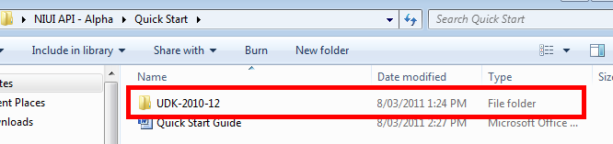

This contains all the files setup in the appropriate directories to allow you to simply copy it over your existing **UDK-2010-12** folder.

**Step 3:**

Copy the **UDK-2010-12** folder and browse to your UDK install directory. Paste the folder over your existing UDK-2010-12 folder.

When asked if you want to copy and replace the existing files, say yes. See below:

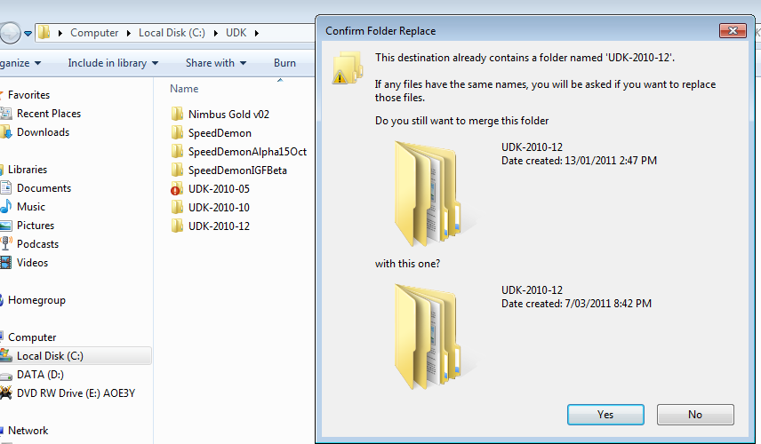

This will add the NIUI.dll, NIUIConfig.xml, the required OpenNI dlls, NIUI content packages, NIUI source code and also setup the UDKEngine.ini file to compile the sample project.

**Step 4:**

We are now going to compile the NIUI scripts. This creates the NIUI script package for the samples and allows all the content in the NIUI_Demo_Content package to be able to be viewed in the editor.

Open Unreal’s Frontend by browsing to it and you should see a window similar to the one below.

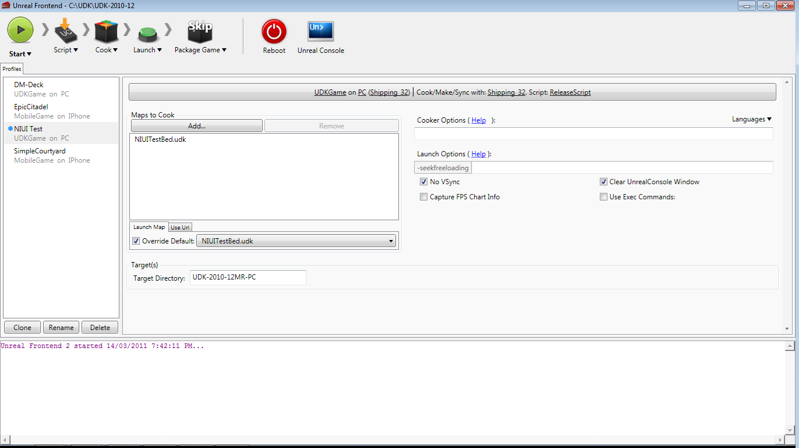

We are now going to compile the scripts by clicking on the small black arrow next to the Script Icon and selecting Full Recompile.

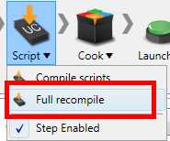

In the log window at the bottom of the main window you should see information being outputted about compiling. When compilation is successful, you will see information similar to below displayed in the log.

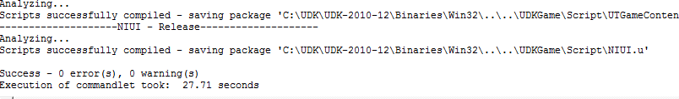

Once Frontend informs you that compilation was successful, you are ready to proceed.

**Step 5:**

We are now going to set up a shortcut that will allow you to directly run the sample demo. This is done through creating a new shortcut on the desktop, directing it to UDK and then passing command line arguments that specify how UDK is to start.

Go to your desktop and right click, then select New, then shortcut.

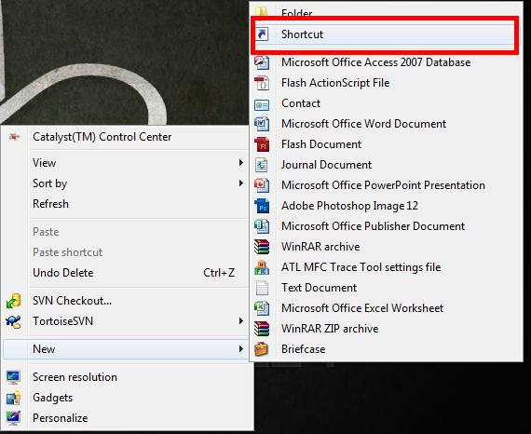

You will be presented with a window similar to the one below.

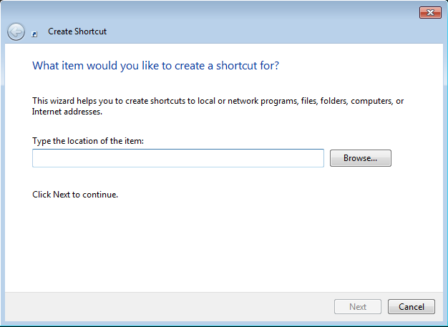

Now we will link the shortcut to startup UDK with some settings that will enable it to startup the sample content.

Do this by pasting in the following:

**"C:\UDK\UDK-2010-12\Binaries\Win32\UDK.exe" NIUITestBed?game=NIUI.NIUI_Main -log**

The above specifies UDK to start with the NIUI code base and open the NIUITestbed map.

After pasting this in, select next and then for the name enter “**NIUI Sample**” and select Finish.

You should have a shortcut similar to the following:

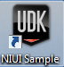

Double click on this to start the NIUI sample and after a short loading step you should be in the sample.

To get the character to move with your body, you will need move your body into the calibration position, which is the position below.

